Chapter 2 Application Layer
1. In the following four descriptions, which one is correct?
A In C/S architecture, clients communicate with each other directly.
B In C/S architecture, client has a fixed well-known address.
C In P2P architecture, peers communicate with each other directly.
D In P2P architecture, peer has a fixed well-known address.
2. In the context of a communication session between a pair of process, the process that initiates the communication is labeled as the , the process that waits to be contacted to begin the session is labeled as the .
A client process, server process B sending process, receiving process
C input process, output process D communicating process, connecting process
3. A socket is the interface between within a host.
A the network layer and the link layer
B the link layer and the physical layer
C the application layer and the transport layer
D the transport layer and the network layer
4. In the following applications, which one is a loss-tolerant application?
A E-mail B file transfer C instant messaging D real-time audio
5. In the following applications, which one is a bandwidth-sensitive application?
A E-mail B web application C real-time audio D file transfer
6. The service of TCP can’t guarantee .
A delivery of all data without error B delivery of all data in the proper order
C the rate of delivery D congestion control
7. In the following applications, which one uses UDP?
A E-mail B web application C file transfer D DNS
8. In the following descriptions about HTTP, which one is not correct?
A HTTP uses non-persistent connections in its default mode.
B HTTP uses TCP as its underlying transport protocol.
C HTTP is a stateless protocol.
D HTTP is client-server architecture.
9. Suppose a web page consists of a base HTML file, 5 JEPG images and a java applet, and also suppose HTTP uses persistent connection without pipelining, the total response time is .
A 2RTT B 8RTT C 12 RTT D 14RTT
10. In HTTP response message, if the requested HTTP protocol version is not supported, the status code is .
A 200 B 301 C 400 D 505

1~5 CACDC 6~10 CDABD
11. The port number of web application is .
A 25 B 20 C 80 D 53
12. A network entity that satisfies HTTP requests on the behalf of an origin web server is .
A server farm B server stack C proxy server D edge server
13. In the following descriptions about persistent connection, which one is not correct?
A The server leaves the TCP connection open after sending a response.
B Each TCP connection is closed after the server sending one object.
C There are two versions of persistent connection: without pipelining and with pipelining.
D The default mode of HTTP uses persistent connection with pipelining.
14. FTP uses two parallel TCP connections to transfer a file, there are .
A control connection and data connection
B receiving connection and sending connection
C client connection and sever connection
D program connection and process connection
15. In the following descriptions about FTP, which one is correct?
A FTP is p2p architecture. B FTP sends its control information out-of-band.
C FTP uses persistent connection. D FTP is a stateless protocol.
16. In the commands of FTP, which one does not have parameter?
A USER B PASS C LIST D STOR
17. The Internet mail system has three components which they are .
A user agent, SMTP, POP3 B SMTP, POP3, IMAP
C user agent, SMTP, IMAP D user agent, SMTP, mail server
18. If the status code in HTTP response message is 404, it means .
A Request succeeded.
B The requested document doesn’t exit on this server.
C This is a generic error code indicating that the request could not be understood by the server.
D Requested object has been permanently mover.
19. Comparison HTTP with SMTP, the correct is .
A HTTP is a push protocol, and SMTP is a pull protocol.
B In the default mode, both of them use persistent connection.
C HTTP places all of the message’s objects into one message, and SMTP sends every object one by one.
D HTTP requires each message to be in 7-bit ASCII format, and SMTP doesn’t impose this restriction.
20. The headers in the MIME message must include except .
A From B Content-type C Content-transfer-encoding D MIME version

11~15CCBAB 16~20 DDBBD
21. In the following protocol, which one is stateless?
A POP3 B SMTP C FTP D IMAP
22. DNS means .
A Data Name System B Data National System
C Domain Name System D Domain National System
23. There are three classes of DNS server except .
A Root DNS server B Local DNS server
C TLD server D Authoritative DNS server
24. DNS provides some services except .
A Host aliasing B Mail server aliasing
C Load distribution D A single point of failure
25. There are three architectures for locating content in P2P file sharing, KaZaA uses .
A Centralized Directory （Napster）
B Query Flooding(Gnutella)
C Exploiting Heterogeneity (p141)
D Incentive Priorities
26. There are three architectures for locating content in P2P file sharing, Napster uses .
A Centralized Directory (p137)
B Query Flooding
C Exploiting Heterogeneity
D Incentive Priorities
27. The following architectures in P2P file sharing, which is an overlay network?
A Centralized Directory
B Query Flooding(p139)
C Exploiting Heterogeneity
D Incentive Priorities

28. The time it takes for a small packet to travel from client to server and then back to the client is .
A round-travel time B next-hop time
C round-trip time D prefix-matching time

29. Suppose A ( with a Web-based e-mail account ) sends a message to B ( who accesses his mail server using POP3), which application-layer protocol is not used?
A HTTP B SMTP C POP3 D IMAP

30. In the four following options, which protocol is included in Mail Access Protocol?
A SMTP B DHCP C IMAP D FTP
31. In FTP commands, is used to send user password to the server.
A User B Pass C Retr D Stor
32. The function of the additional header field in MIME Content-Type is .
A to convert the message body to its origin non-ASCII form

B to determine what actions it should take on message body
C to send an E-mail to the receiving user agent
D to indicate what type the message is
33. In the four following options, which application is organized as hybrid of C/S and P2P architecture?
A E-mail B OICQ C File transfer D Web application
34. In the four following options, which is not a centralized DNS design’s problem?
A a single point of failure
B traffic volume
C distant centralized database
D slow (maintenance)
- In the following options, from the application developer’s perspective, which is not correct?
A the network architecture is fixed
B the network architecture provides a specific set of services to applications
C the application architecture is designed by the physical devices
D the application architecture dictates how the application is organized over the various end systems
36. There are three predominant architectures used in modern network applications, which one is not included?
A the client-server architecture B the P2P architecture
C a hybrid of the client-server and P2P architecture
D a hybrid of the client-server and browser-server architecture
37. In the following options about C/S architecture, which is not correct?
A In C/S architecture, there is an always-on host, called the server.
B In C/S architecture, there is an always-on host, called the client.
C The server has a fixed, well-known address, called IP address.
D Clients do not directly communicate with each other.
38. are often used to create a powerful virtual server in C/S architecture.
A Peers B Server farm C server stack D local server
39. A process sends messages into, and receives messages from, the network through its .
A socket B program C client D peer
40. Which one is not defined by an application-layer protocol?
A the types of messages exchanged
B the syntax of various message types
C the semantics of the fields
D rules for determining when and how to translate the socket
41. HTTP can use two types of connections, which are .

A persistent and non-persistent connection
B connection with pipelining and without pipelining
C TCP and UDP
D parallel and serial connection
42. takes for a small packet to travel from client to server and then back to the client.
A RDT B threshold C RTT D overhead
43. The default mode of HTTP uses .
A non-persistent connection with pipelining
B non-persistent connection without pipelining
C persistent connection with pipelining
D persistent connection without pipelining
44. In HTTP request messages, the request line has three fields, there are .

A the method field, the URL field and the HTTP version field
B the method, the connection and URL field

C the user-agent, the method and HTTP version field
D the user-agent, the URL and the HTTP version field
45. In the header lines of HTTP request message, if the field of Connection is close, it specifies .
A the host on which object resides
B what type of the user agent
C that the browser wants the server to close the connection after sending the requested object

D which language can the browser receive
46. In HTTP response message, if the status code is 404, it means .
A request succeeded and the information is returned in the response

B requested object has been permanently moved
C the requested HTTP protocol version is not supported by the server

D the requested document does not exist on this server

47. is a network entity that satisfies HTTP requests on the behalf of an origin Web server.
A proxy server B local server C DNS server D Web server

48. In the following four options about web cache, which one is not correct?
A A web cache is both a server and a client at the same time.
B A web cache is purchased and installed by an ISP.
C A web cache can raise the response time for a client request.
D A web cache can reduce traffic on an institution’s access link to the Internet.
49. The request message in the conditional GET must include the header line.
A Last-Modified B Last-Referenced
C If-Modified-Since D If –Referenced-Since
50. FTP uses two parallel connections to transfer a file, they are .
A TCP and UDP connection

B connection with pipelining and without pipelining
C control an data connection
D client-server and browser-server connection
51. In FTP commands, which one is used to ask the server to send back a list of all files in the current remote directory?
A USER B PASS C LIST D RETR
52. In the Internet mail system, allow users to read, reply to, forward, save and compose message.
A User agents B mail servers C SMTP D TCP
53. The two key MIME headers for supporting multimedia are .
A Content-Type and MIME-Version

B Content-Type and Content-Transfer-Encoding
C Content-Transfer-Encoding and MIME-Version

D MIME-Version and MIME-Type
54. For Internet mail, the mail access protocol is used to .
A transfer mail from the recipient’s mail server to the recipient’s user agent
B transfer mail from the sender’s mail server to the recipient’s mail server

C translate the mail from the sender’s mail server
D translate the mail into the recipient’s mail server
55. POP3 progresses through three phases, which they are .
A authorization, translation and transaction
B authorization, translation and update
C authorization, transaction and update
D translation, transaction and update
56. In the following four services, which one can not provide by DNS?
A Host aliasing B Mail server aliasing
C translate hostname to IP addresses
D translate MAC addresses to IP addresses
57. There are three classes of DNS servers, there are .
A root DNS server, top-level domain DNS server and local DNS server
B root DNS server, top-level domain DNS server and authoritative DNS server

C root DNS server, local DNS server and authoritative DNS server
D root DNS server, local DNS server and top-level domain DNS server
58. In the following four options about POP3, which one is not correct?
A The user agent employed only three commands: List, Retr and Quit
B The server does not carry state information across POP3 sessions
C The port number is 110
D The POP3 protocol does not provide any means for a user to create remote folders and assign messages to folders.
59. A resource record in DNS distributed database is a four-tuple, which field can be ignored?(p132) A Name B Value C Type D TTL
60. In the following four options about DNS
resource record, which one is correct?
A The meaning of Name and Value depend on Type.
B The meaning of Value and Type depend on Name.
C If Type=A, then Name is a domain and Value is the IP address for the hostname.
D If Type=MX, then Name is domain and Value is the IP address for the hostname.
61. In the following four options about DNS messages, which one is not correct?
A There are only two kinds of DNS message.(p133)
B Both query and reply message have the same format.
C The header section in DNS message has 12 bytes.
D The authority section contains the resource records for the same that was originally queried.
62. In DNS message, contains information about the query that is being made.(p133)
A authority section B question section C answer section D additional section
63. There are three techniques are employed in most any P2P file-sharing systems, which one is not include? （p144）
A Request queuing B incentive priorities C parallel downloading D Response queuing
64. In the following four options about P2P file-sharing, which one is not correct?
A P2P file-sharing is highly scalable.
B P2P file-sharing relies on P2P architecture.
C The means for locating content in different P2P file-sharing are different.
D P2P file-sharing systems not only share MP3s,but also videos, software, documents and images.
65. In MIME header lines, specifies the name of the SMTP server that sent the message (from),
the name of the SMTP server that received the message (by), and the time an which the receiving server received the message.
A Received B From C To D MIME-Version
66. If the header line Connection is close, it means that the client wants .
A persistent connection with pipelining
B persistent connection without pipelining
C nonpersistent connection
D not connection
67. In HTTP request message, the entity body is empty with the method, but is used with the method.
A GET, POST B POST,GET C GET, HEAD D POST, HEAD
68. In HTTP response message, if the Date: header ;one indicates the time Fri. 08 Aug. 2008 12:00:00 GMT, the Last-Modified: header line can not be .
A Fri. 08 Aug. 2008 11:00:00 GMT B Fri. 08 Aug. 2008 11:30:00 GMT
C Fri. 08 Aug. 2008 12:00:00 GMT D Fri. 08 Aug. 2008 12:30:00 GMT
69. In the following four options, which one is not the part of cookie technology?
A Cookie header lines in the HTTP response message and request message.
B One cookie header file kept on the user’s end system and managed by the user’s browser.
C A network entity that satisfies HTTP requests on the behalf of an origin Web server.

D A back-end database at the Web site
70. On-top of stateless HTTP, can be used to create a user session layer.
A proxy server B Web cache C cookie D socket
71. Processes communicate with each other by reading from and writing to .
A programs B threads C sockets D channels
72. In the following four options about network architecture, which one is not correct?
A The network architecture is fixed.
B The network architecture provides a specific set of services to application.
C The network architecture is designed by application developer.
D The network architecture dictates how the application is organized over special server.
73. In Client-Server architecture, the clients visit the server’s through .
A client’s socket B client’s IP address
C server’s socket D server’s IP address
74. can be thought of as a program that is running within end system.
A process B thread C socket D context
75. API means .
A Application Program Interface B Application Process Interface
C Appellation Program Interface D Appellation Process Interface

76. One host can be running many network applications, so the system assigns them different
to distinguish each other.
A IP address B port number C hostname D section

77. In the following four applications, which one is both bandwith-sensitive and require tight timing constraints?
A real-time audio B file transfer C E-mail D Web documents
78. The port number of the Web server is .
A 25 B 20 C 80 D 8080
79. The port number of the mail server is .
A 25 B 20 C 80 D 8080
80. Look the URL http://www.djtu.edu.cn/rjxy/index.html, the object’s path name is .
A www.djtu.edu.cn B www.djtu.edu.cn/rjxy
C /rjxy/index.html D index.html
81. Each URL has components, they are .
A transport protocol and object’s path name
B host name and object’s path name
C transport protocol and host name
D client name and server name
1. Consider an HTTP client will request a WEB page from a WEB server. Suppose the URL of the page is www.stdjtu.edu.cn/somedepartment /somedir/exp.html. The client does not want to use persistent connections and want to receive French version of the object. The user agent is Windows NT 5.1. Give the request message according to the given format.

Request line:
Header lines:

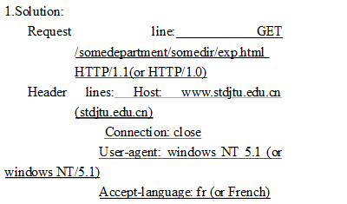
2. Telnet into a Web server and send a multiline request message. Include in the request message the If-modified-since: header line to force a response message with the 304 Not Modified status code.
Solution:
Request line:
Header lines:

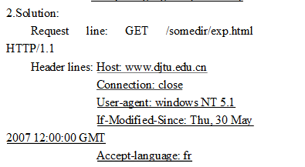
3. Suppose within you Web browser you click on a link to obtain a Web page. The IP address for the associated URL is not cached in your local host, so a DNS look-up is necessary to obtain the IP address. Suppose that n DNS servers are visited before your host receives the IP address from DNS; the successive visits incur an RTT of RTT₁,…，RTT_{n}. Further suppose that the Web page associated with the link contains exactly one object, consisting of a small HTML text. Let RTT₀ denote the RTT between the local host and the server containing the object. Assuming zero transmission time of the object, how much time elapses from when the client clicks on the link until the client receives the object?
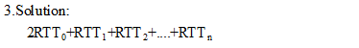
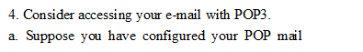
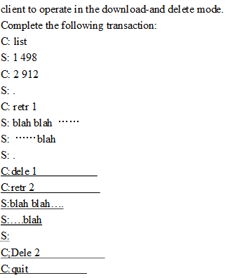
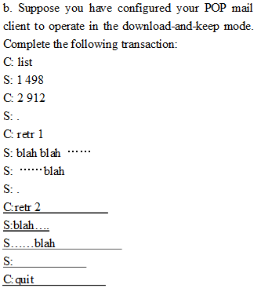
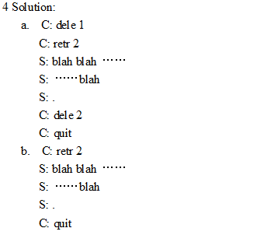
5. Suppose that you send an e-mail message whose only data is a microsoft excell attachment. What might the header lines (including MIME lines) look like?
